
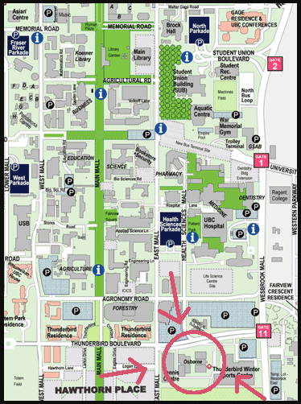
Map of where Osbourne Gym is located.

Map of where Osbourne Gym is located.

2007 – 2008

2007 - 2008

